TASK ON Terraform-02
1). Watch the Terraform-02 video.
Done watching the video
2). Execute all the templates shown in the video.
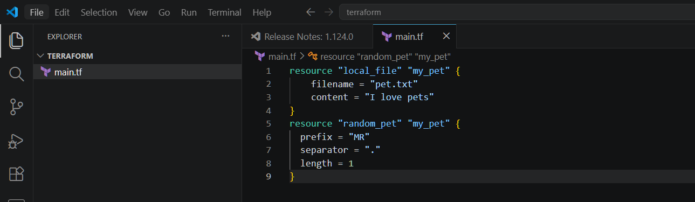
terraform init
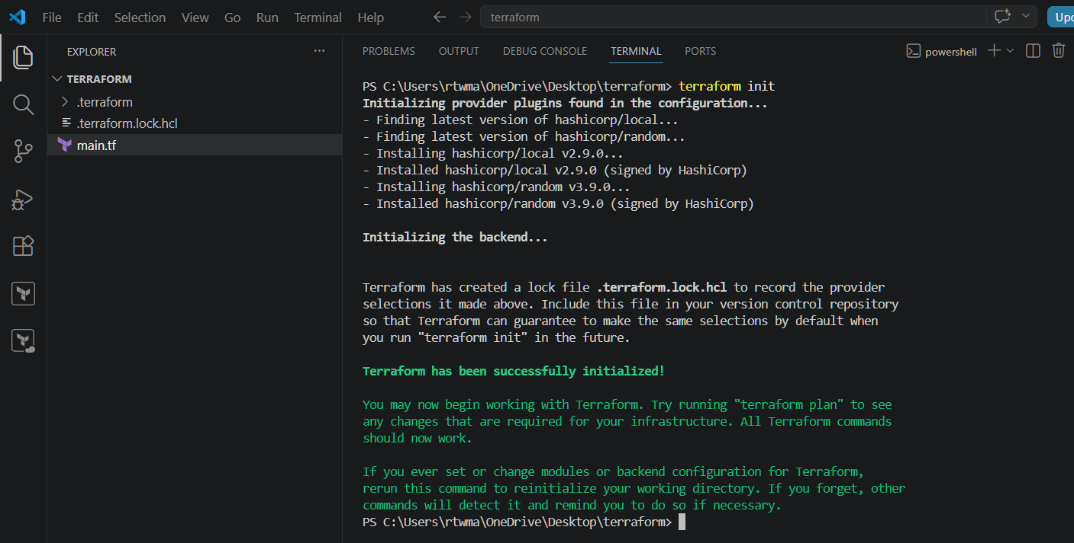
Terraform plan
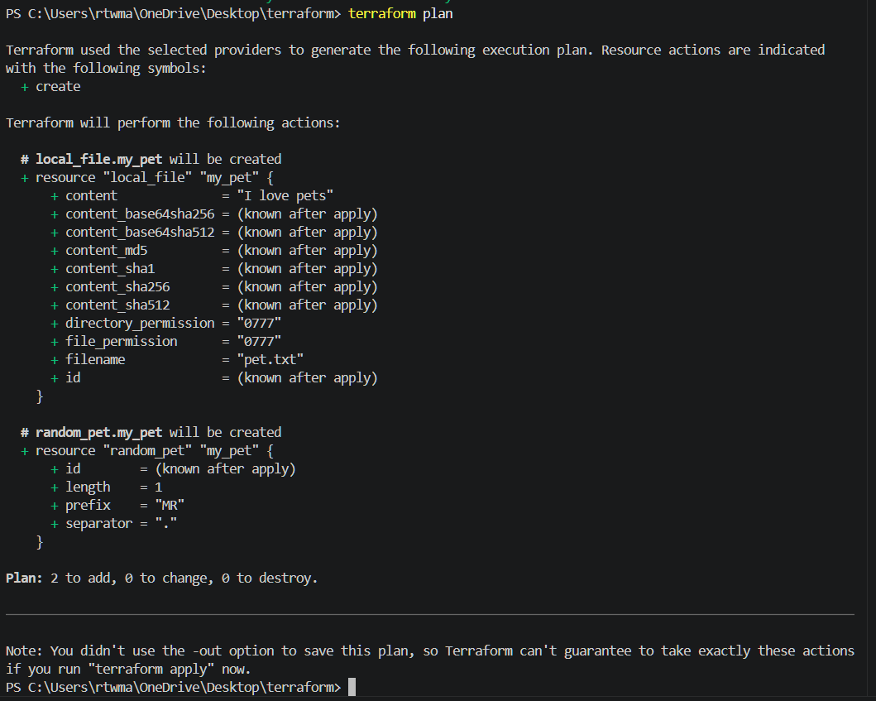
terraform apply
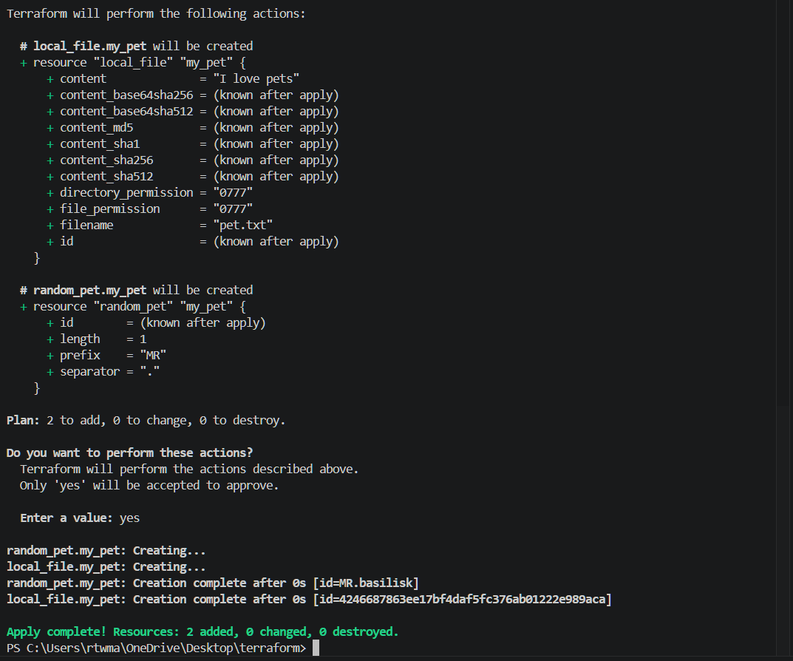
Now lets create variable.tf file
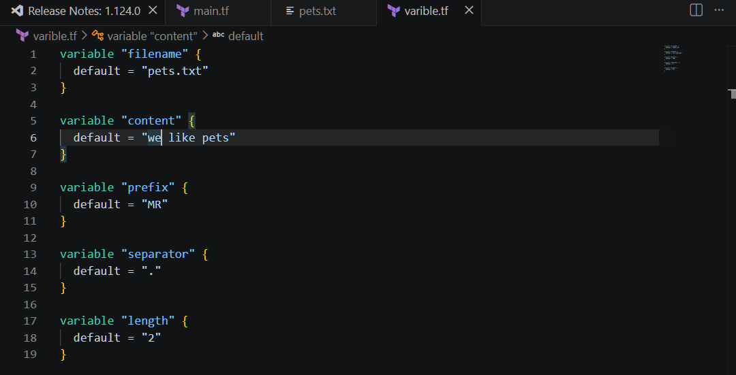Instead of hard coding the values inside main.tf file we have created a variables.tf. So main.tf will use those variables with var.content, var.filename etc
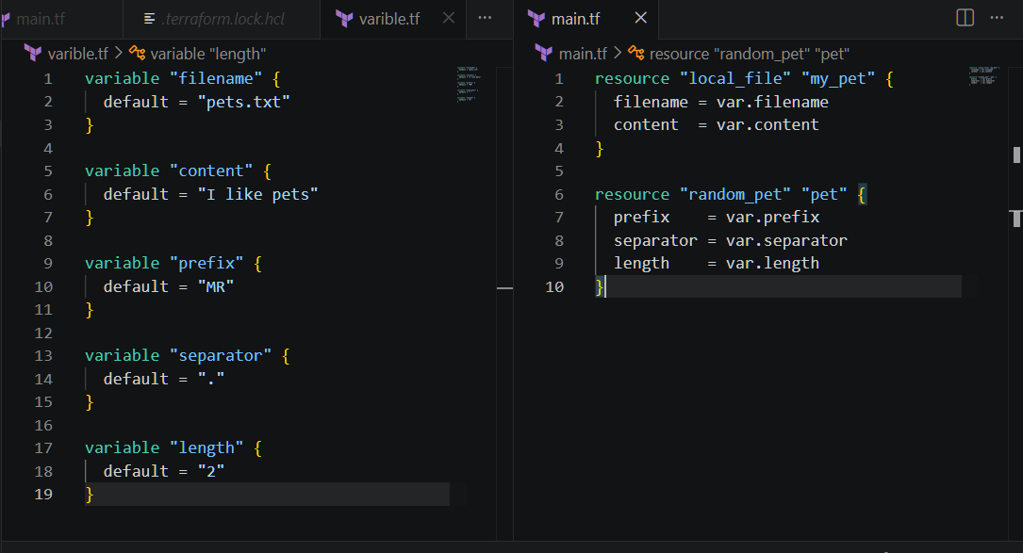
Now perform terraform apply

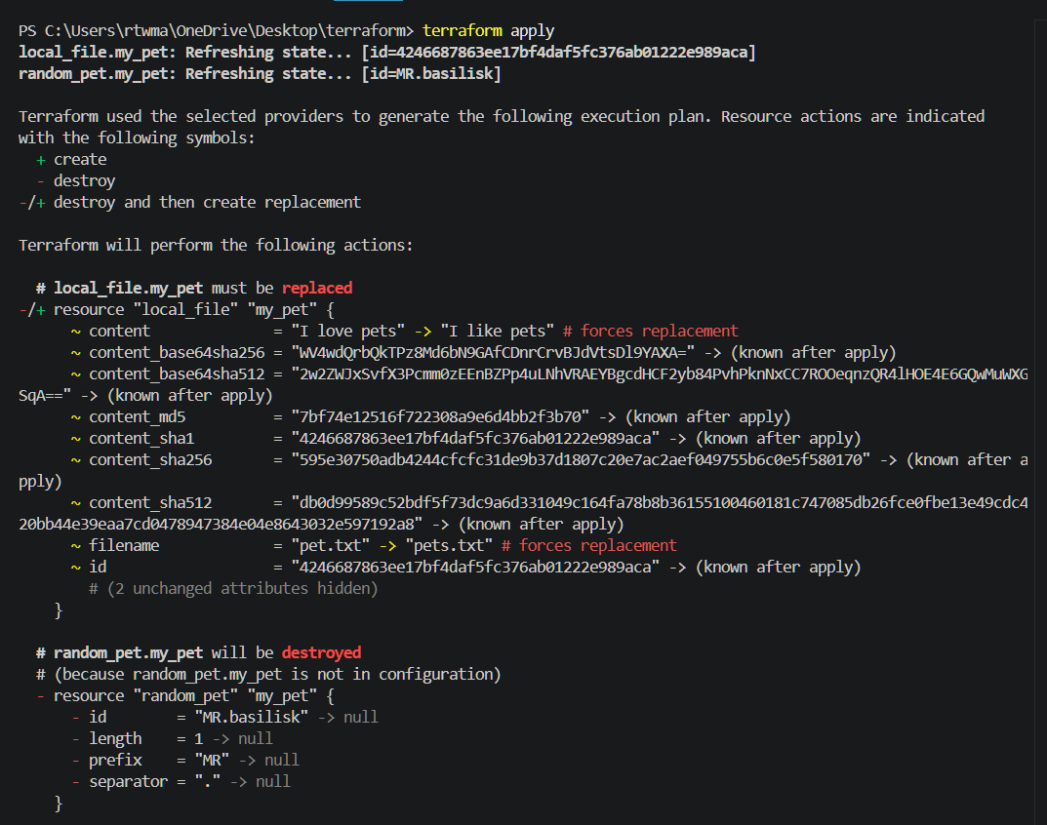
The content is changed here
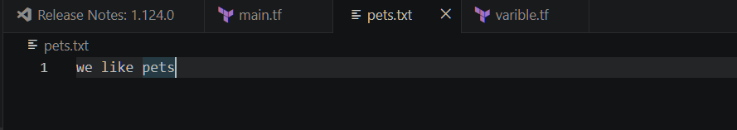
3). Integrate Terraform in Jenkins using the Terraform plugin.
Installed terraform plugin
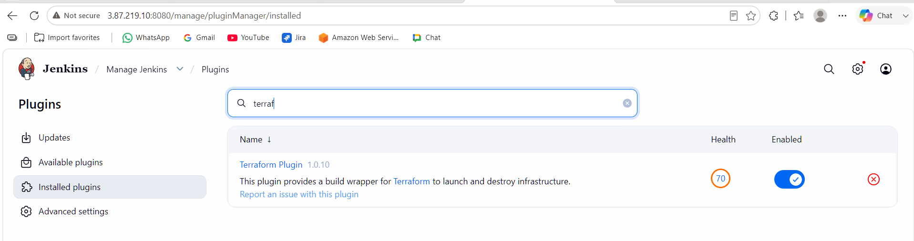
Tools terraform installation give name save
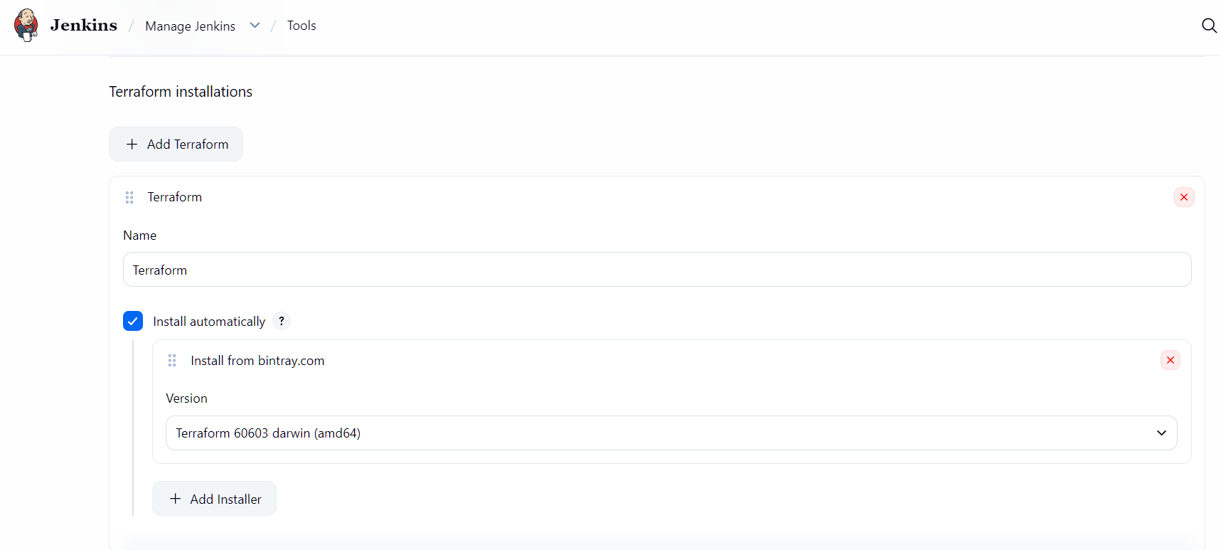
Lets create main.tf file
First I have created a job and added and pipeline and build it ,then I got test.tf file
pipeline {
agent any

stages {

stage('Hello') {
steps {
echo 'Jenkins Pipeline Started'
}
}

stage('Check Server') {
steps {
sh '''
whoami
hostname
pwd
date
'''
}
}

stage('Create File') {
steps {
sh '''
echo "Hello Jenkins" > test.txt
cat test.txt
'''
}
}

stage('Complete') {
steps {
echo 'Pipeline Executed Successfully'
}
}
}
}
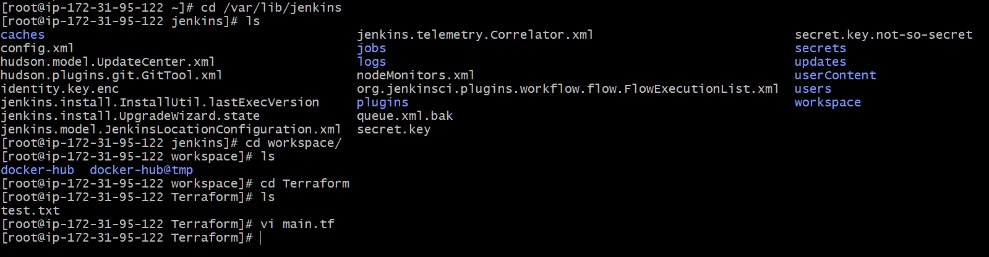
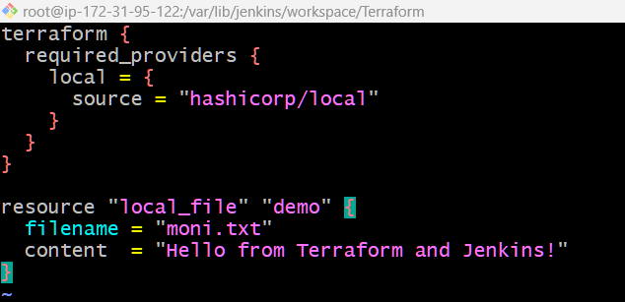

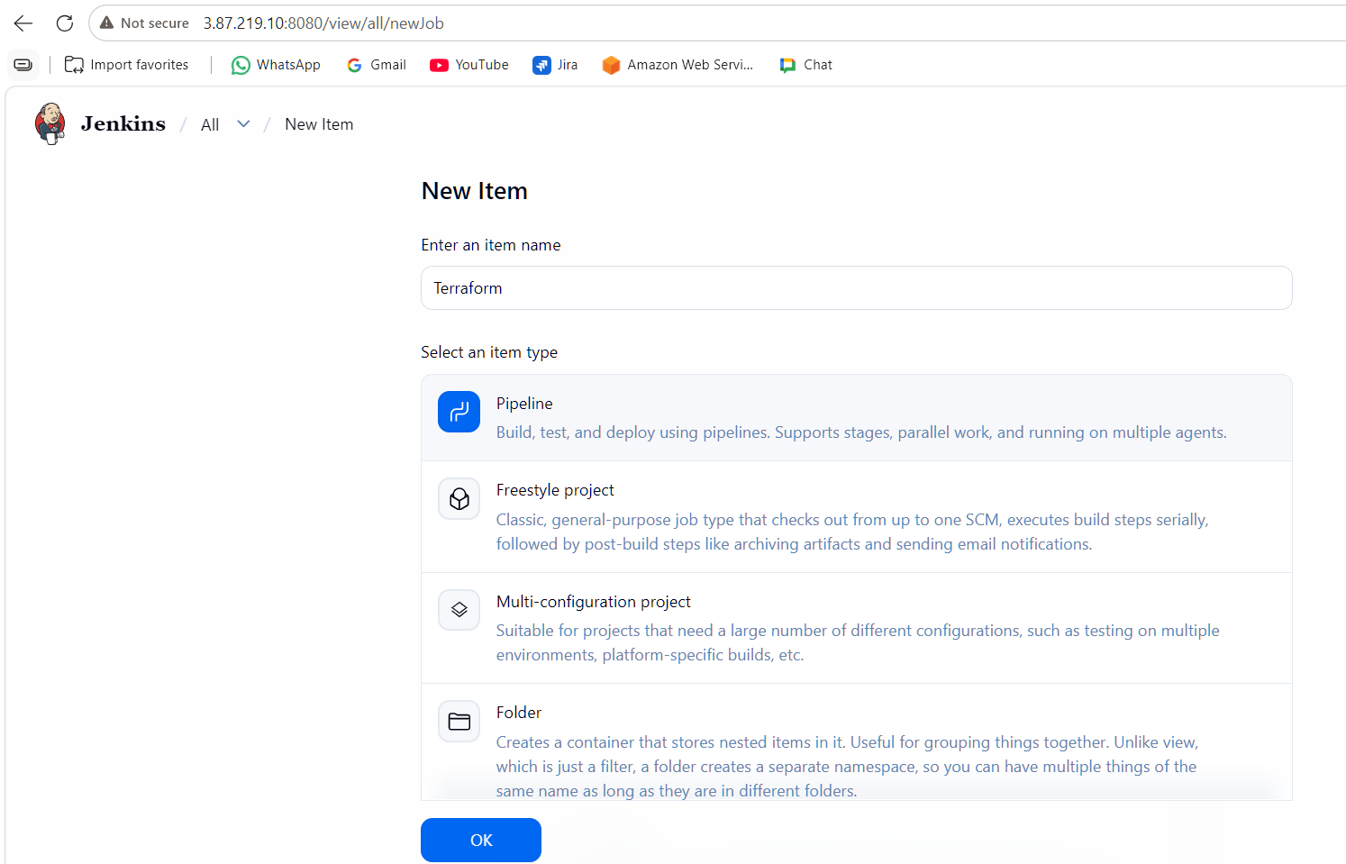
Write piprline script
pipeline {
agent any

stages {

stage('Terraform Init') {
steps {
sh '/usr/bin/terraform init'
}
}

stage('Terraform Plan') {
steps {
sh '/usr/bin/terraform plan'
}
}

stage('Terraform Apply') {
steps {
sh '/usr/bin/terraform apply -auto-approve'
}
}

}
}

The pipeline is build successfully
